Computer Programming
April 13 - 17

What you will need:
Computer/device
Internet
School e-mail/TEAMS/CodeHS

What you will do:

M 4/13 | T 4/14 | W 4/15 | Th 4/16 | F 4/17
Add a photo of YOURSELF to our Teams classroom  Lesson: Intro to CS: Javascript PreTest | Begin Unit 1- Programming with Karel  Watch Video 1.1.1  Take Quiz 1.1.2 | Work the Example 1.1.3 Our First Karel Program | Begin 1.1.4 Your First Karel Program (work on this for at least 20 minutes) | Continue 1.1.4 (20 minutes)  Post to TEAMS Discussion Board
Use the boxes below to CHECK when above task is completed (optional):

What you will learn:
Personalize your Teams account. Learn beginning JavaScript

How you will complete your work:
Add a Photo:
We miss you and it will be great to see your face! Add a NICE and school appropriate photo of yourself to our Teams classroom!

- Go to your Team classroom. In the upper right corner, click the circle for your profile. Click “Change picture”
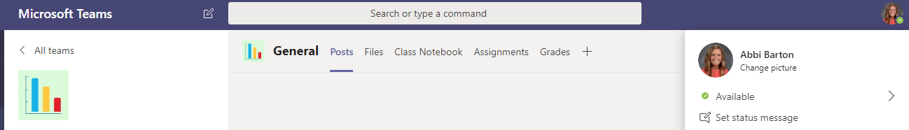

- In the next window, click “Upload picture.” Find the photo saved in your files.

Don’t have a photo? EMAIL ME! I will send you your yearbook photo

Unit 1: PreTest:
See where you stand with JavaScript. Some of you might have some experience!

Unit 1: Programming with Karel
Click the “Plus” sign to View Lessons.
Click PLUS sign to expand
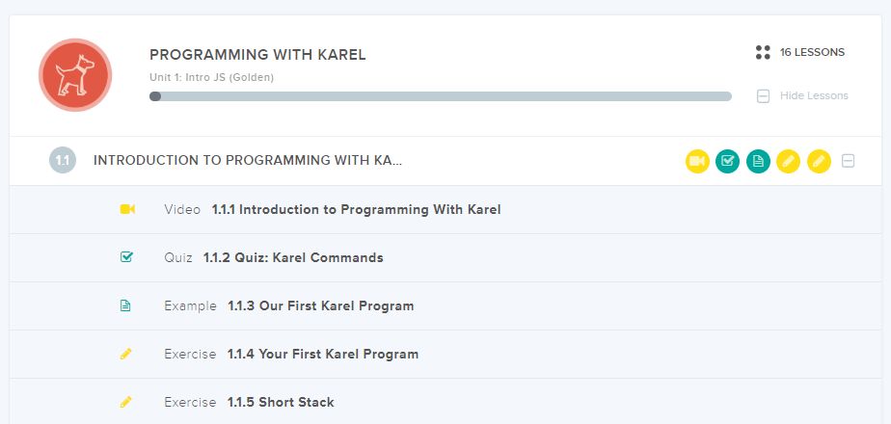

Make a POST in Computer Programming DISCUSSION BOARD:
- Open your Class, one the left side, click Discussion Board.

- Discussion Topic: What has worked for you/What has not?
Some ideas to consider: What tips can you give your classmates? (You MAY include lines of code to help each other) What are you struggling with? What was difficult? How did you figure out a difficult task? What do you need help with?

You can post COMMENTS or Questions

Select GENERAL on the left hand side to get back to our classroom.

“See” you next week!

